DARBARI LAL DAV MODEL SCHOOL, PITAMPURA

CELEBRATES

AZADI KA AMRITOTSAV 2022



[CLICK HERE](https://youtu.be/QK0pXomIFBs)

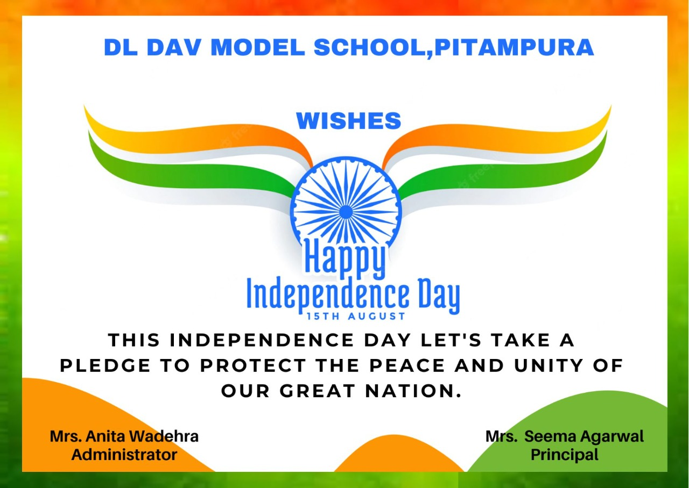

**Darbari Lal DAV Model School, N D Block Pitampura celebrated the 75th Independence Day**

**-Azadi ka Amritotsav with great zeal and zest. The celebration was spread over a number of days with an array of activities and competitions to arouse patriotic fervor and pride for the glorious history of the country.**

**Special Assemblies were organised by different wings of the school ie. Nursery, Primary, Cambridge, Middle, Senior and Senior Secondary.**

**Principal Mrs. Seema Agrawal hoisted the National flag on 13th August 2022 followed by National Anthem and National song. The school choir presented a medley of patriotic songs accompanied by a talented orchestra team. Mesmerizing dances showcasing the incredible diversity of the country, yet bonded by a unique sense of unity captivated the audience. Poems on the significance of the day were recited to infuse love for the country. The bagpiper band of the school impressed one and all. The sight of hundreds of students waving the National flag with reverence and pride was indeed soul stirring.**

**The celebration was flagged off by different competitions organised for different classes and Houses of the school. These included slogan writing on kites, badge making, poster making, folder making and others. The competitions elicited an overwhelming response from students who participated with great enthusiasm. The winning entries were displayed on bulletin boards. The school wore a festive look with hundreds of National flags adorning every nook and corner of the school. The selfie point depicting the "Har Ghar Tiranga" program attracted children and teachers alike. Tricolor balloons were released symbolizing the march of the nation to glory and height. The kite flying competition organised for senior secondary classes filled the entire atmosphere with awe and jubilation.**

**Prabhat pheries were taken out by students and teachers in the neighborhood. Students holding tricolours in their hands and singing patriotic songs drew the attention of the crowds who cheered them with joy.**

**School Principal Mrs. Seema Agrawal expressed great happiness on the celebration of Azadi ka Amritotsav and urged students to remember the unbelievable sacrifices made by our freedom fighters. She reminded them of their responsibilities and remarkable role they would play in nation building. She conveyed gratitude to the authorities for the meticulous planning and execution of the National festival and its tremendous impact on every student and staff of the school. She hoped that the occasion would instill essential values and principles in students to last a lifetime.**